North Shropshire Green Party
Manifesto for Oswestry Elections in May 2021

 | Providing a low carbon connection to the mainline railway.
 | Making Oswestry Town Council carbon neutral.
 | Improve bio-diversity and planting 17,000 trees.
 | Providing a skatepark and more youth services.
 | Working with SUC to build Council housing.
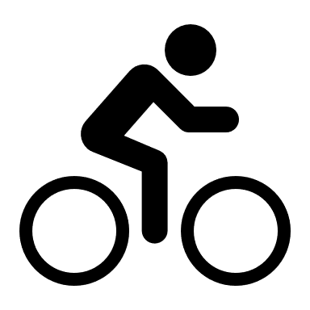 | Campaigning for 20s Plenty.
 | Tackling litter, graffiti and dog waste.
 | Reducing the number of empty shops.
 | Working with the Police to prevent anti-social behaviour.
 | Developing a new tourist attraction in Oswestry.

